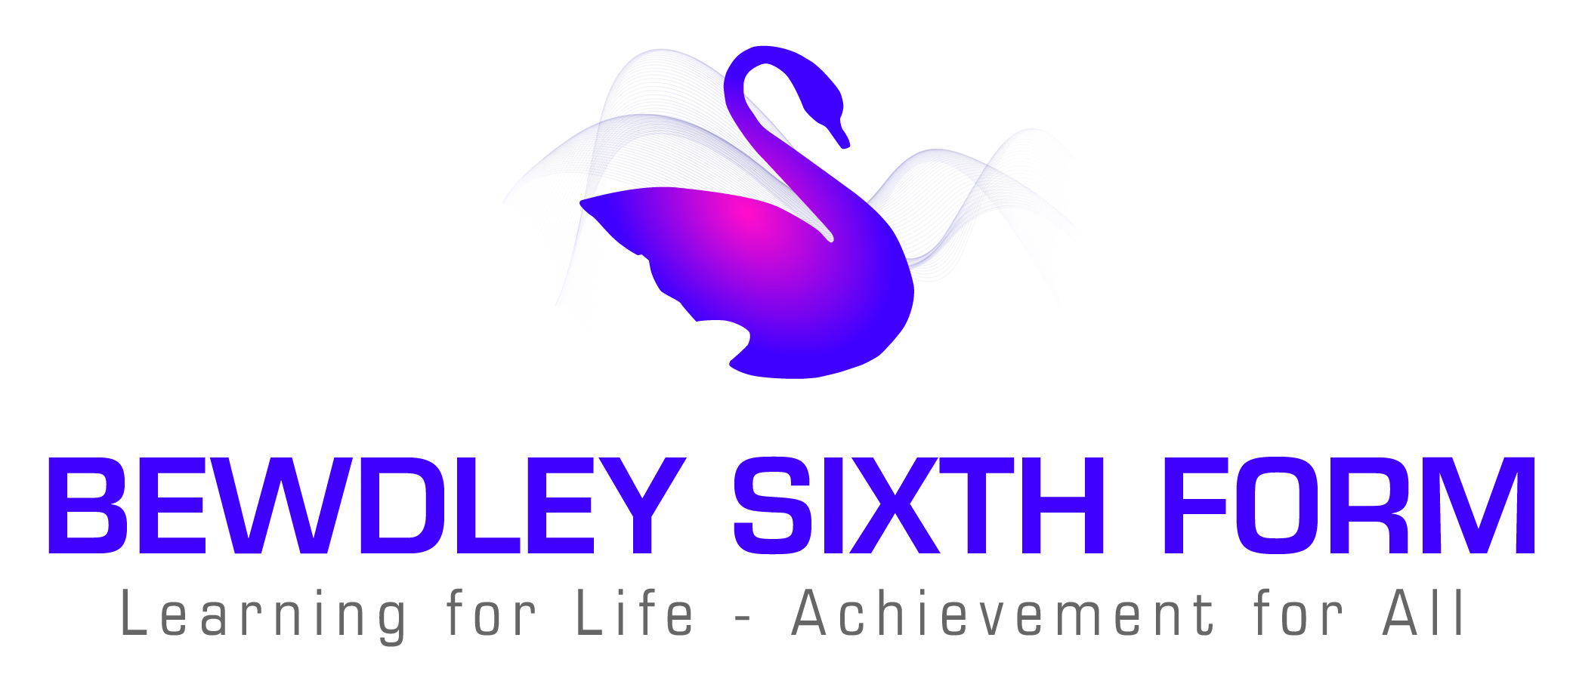

Bewdley Sixth Form
Learning for Life – Achievement for All

Application for Admission to the Sixth Form
Closing Date: 1st February 2018

Personal details
Surname
First name (in full)
Address

Date of Birth
Contact phone Number
Email address
Current School

Education to date:
Please list the qualifications that you are currently studying and the grades that you are predicted
Subject | Qualification  (eg GCSE) | Predicted Grade

Sixth Form courses requested
Please indicate 3 courses that if successful you would like to study in Year 12. Please also include a reserve choice.

Courses
1
2
3
Reserve
Bridging Course (please tick if you are interested in the Bridging Course)

Personal Statement
Please comment on achievements and interests in and out of school, what you can offer our Sixth Form Centre and reasons for your choice of subjects, together with any long term career plans.

Signed………………………………………………….. Date………………..…..
(Student’s signature)
Please return to:
Mrs K. Howard, Head of Sixth Form
C/o Main School Office
The Bewdley Sixth Form
Tel: 01299 403277 Fax: 01299 405480 Email: kho@bewdley.worcs.sch.uk

