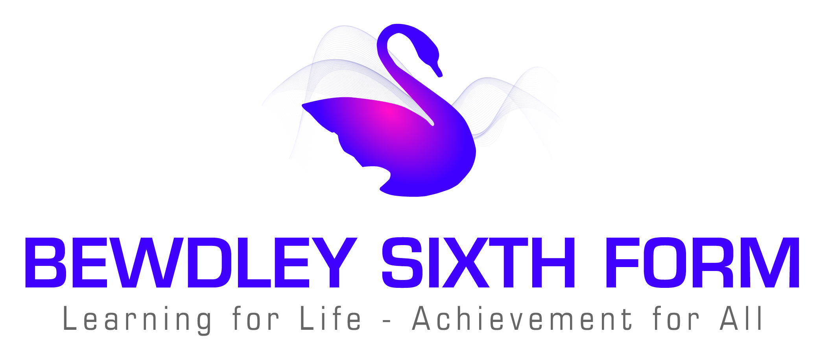

Bewdley Sixth Form
Learning for Life – Achievement for All

Application for Sixth Form
Closing Date: 3rd December 2018

Personal Details
Surname
First name (in full)
Email address
Tutor Group

Sixth Form Courses

Please indicate 3 courses that if successful you would like to study for 2 Years in the 6th Form. Please also include a reserve choice.

Courses
1
2
3
Reserve
Bridging Course (please tick if you are interested in the Bridging Course)

Personal Statement
Please comment on achievements and interests in and out of school, what you can offer our Sixth Form and reasons for your choice of subjects, together with any long term career plans.

Signed………………………………………………….. Date………………..…..
(Student’s signature)

Please return to:
Mrs K. Howard, Head of Sixth Form,
C/o Main School Office
The Bewdley Sixth Form
Tel: 01299 403277 Fax: 01299 405480 Email: kho@bewdley.worcs.sch.uk

